**Mouse Events**

https://www.youtube.com/watch?v=ZAR8agZ-Qj0&list=PLRtjMdoYXLf776y4K432eL_qPw4na_py3&index=5

#include "stdafx.h"

#include "SFML/Graphics.hpp"

#include <iostream>

int main()

{

sf::RenderWindow window (sf::VideoMode(600, 600), "SFML works!");

while (window.isOpen()) {

sf::Event event;

while (window.pollEvent(event)) {

switch (event.type) {

case sf::Event::Closed:

window.close();

break;

case sf::Event::MouseButtonPressed:

switch (event.key.code) {

case sf::Mouse::Right:

std::cout << "Right mouse button pressed" << std::endl;

break;

case sf::Mouse::Left:

std::cout << "Left mouse button pressed" << std::endl;

break;

}

break;

case sf::Event::MouseButtonReleased:

switch (event.key.code) {

case sf::Mouse::Left:

std::cout << "Left mouse button released" << std::endl;

break;

case sf::Mouse::Right:

std::cout << "Right mouse button released" << std::endl;

break;

}

break;

}

}

window.clear();

window.display();

}

}

(suggested to copy-paste the code for into an IDE for proper examination)

**Result**

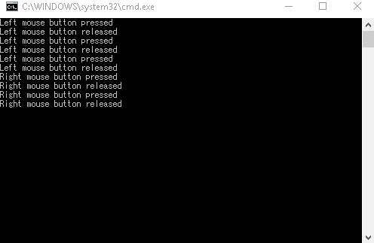

**Important points:**

* while (window.pollEvent(event)) this code triggers every time the mouse makes a movement
* Be sure to break every case statements